PROJECT REPORT

INDIA’S AGRICULTURAL CROP’S PRODUCTION ANALYSIS(1997-2021)

TEAM DETAILS:

TEAM LEADER : M.PUSHPA

TEAM MEMBERS : K.VIGNESHWARI,K.SUJI

1.INTRODUCTION :

1.1OVERVIEW:

First I created an EMPATHY MAP . A map has four quadrants –says,thinks,Does and Feels.next .How do I Prepare for tableau interview.How do you measure the talent management success.What are the critical issues that a talent scorecard should measure?this are all things I shown in my four quadrants.Next I created BRAIN STROM.My team members give some idea for this brainstorm.then I created my data analysis_ Dashboard and story Next I published my Dashboard and story in the Tableau Public.

1.2 PURPOSE :

The purpose of the India’s Agriculture is supporting

Livelihoods through food,habitat,and jobs; providing raw materials for food and other products;and building strong economics through trade.

2.PROBLEM DEFINITION & DESIGN THINKING:

2.1EMPATHY MAP:

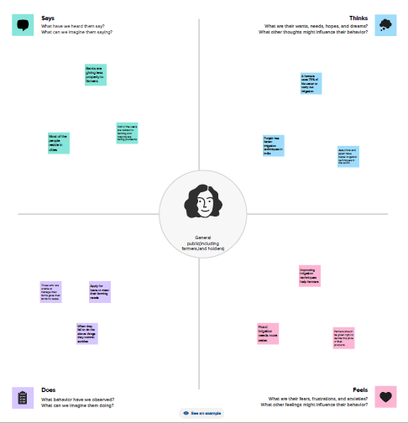

2.2 IDEATION &BRAINSTORMING MAP:

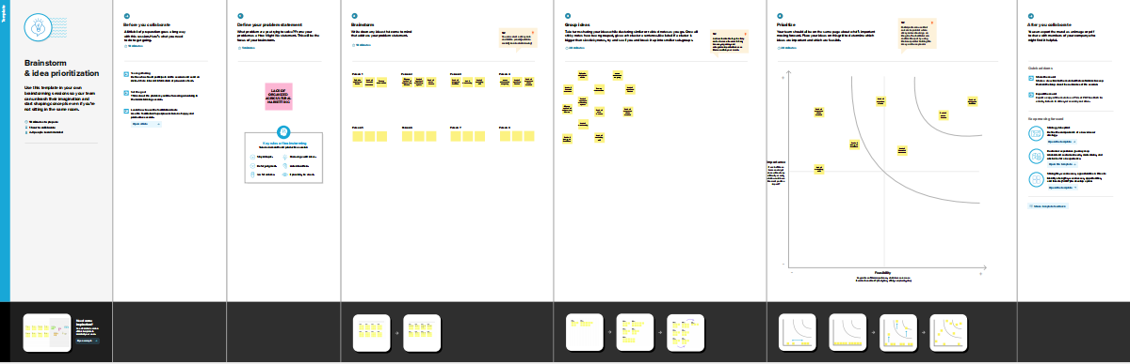

3.RESULT:

DASHBOARD:1

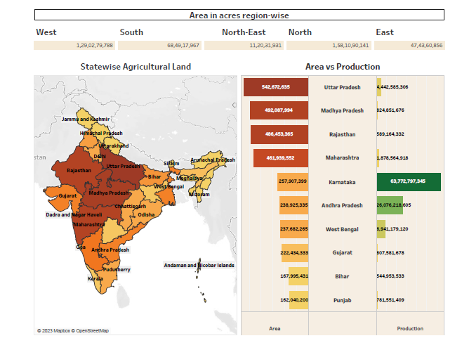

DASHBOARD: 2

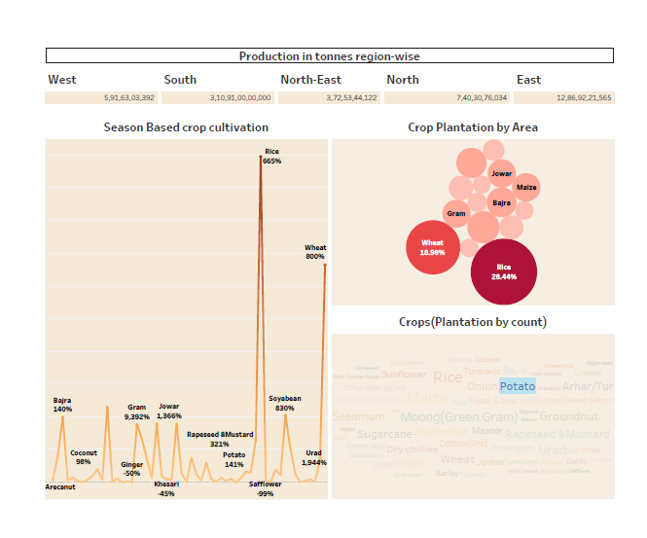

DASHBOARD: 3

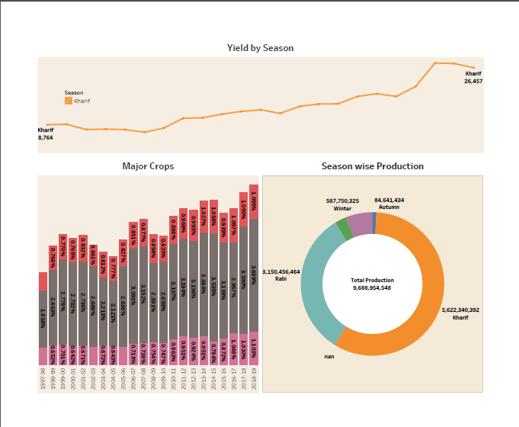

STORY:1

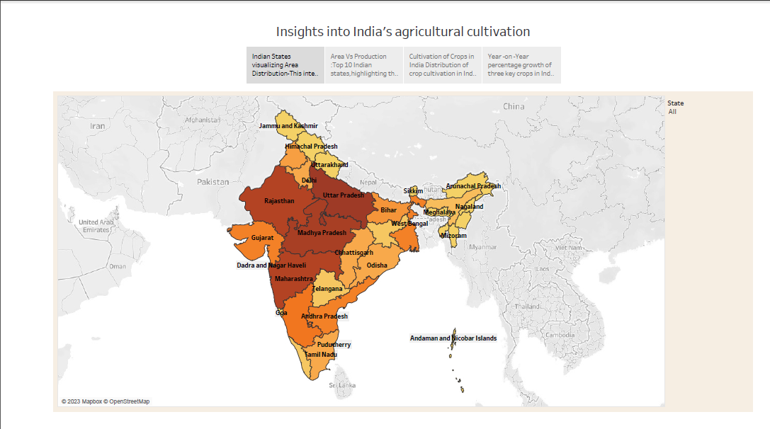

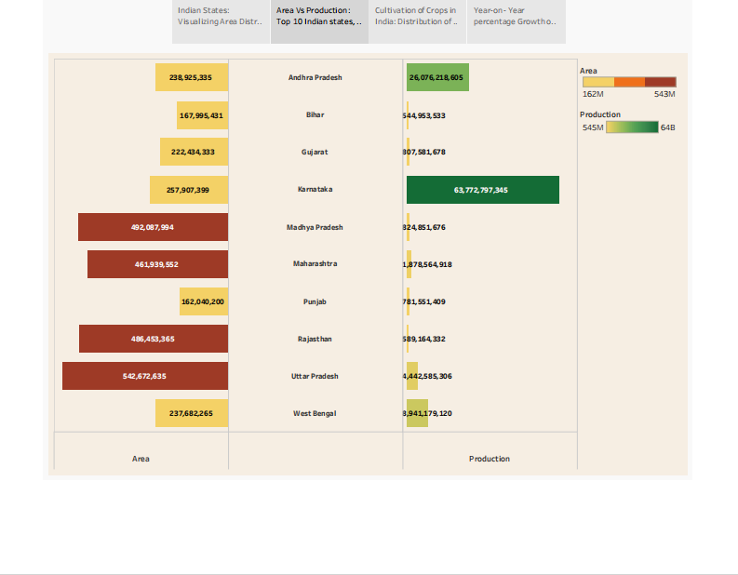

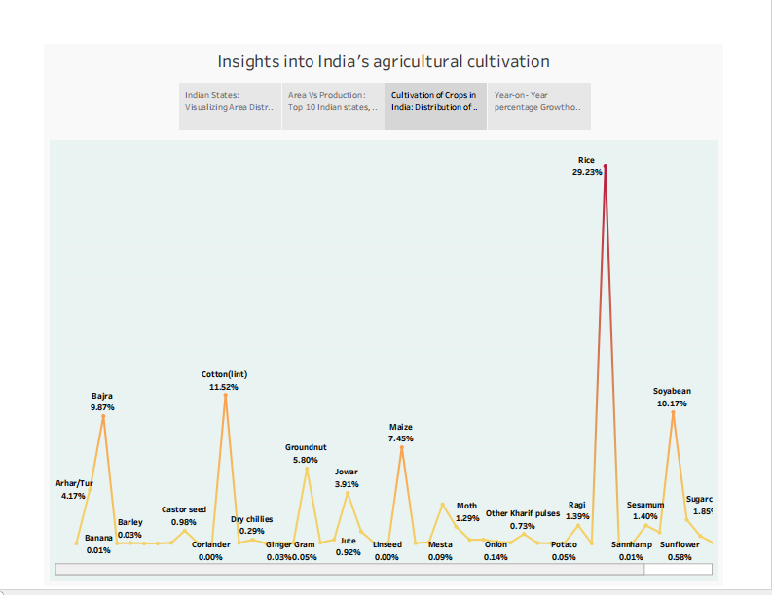

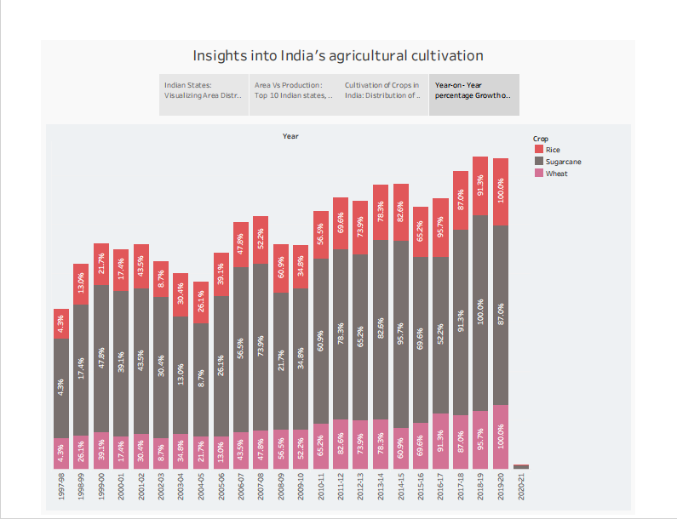

STORY: 2

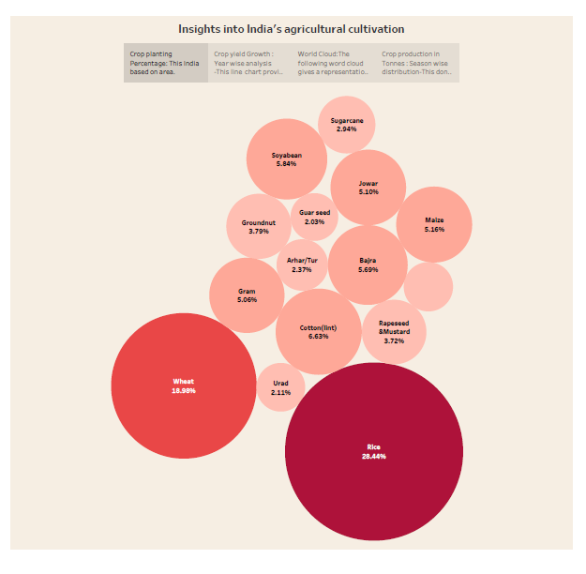

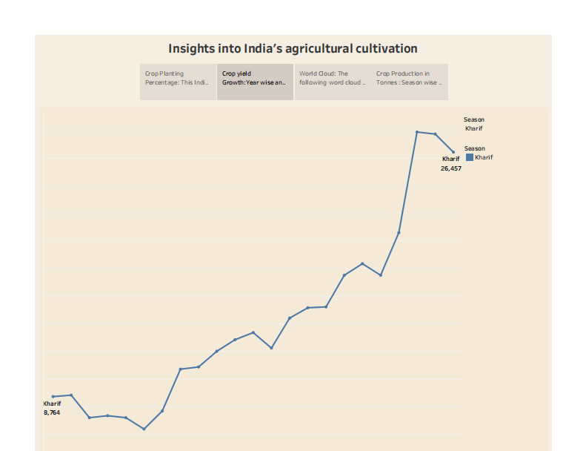

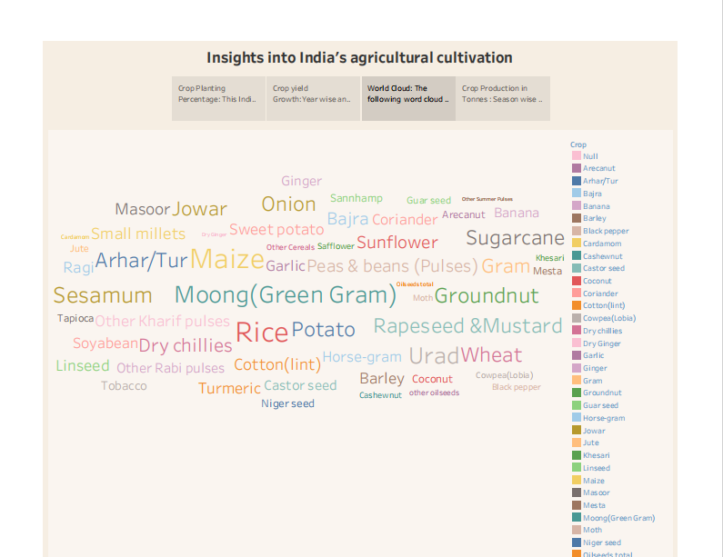

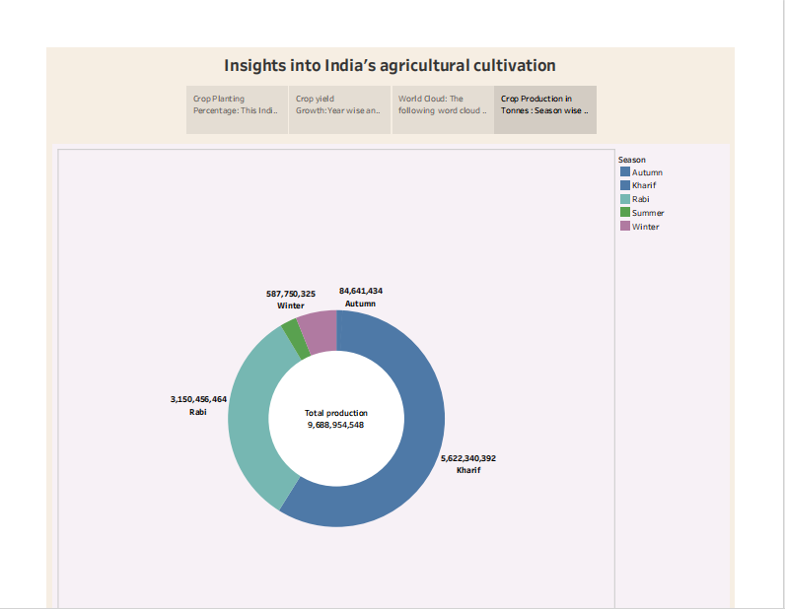

4.ADVANTAGES & DISADVANTAGES:

ADVANTAGES:

Supporting livelihoods through food,habitat,and jobs; providing raw materials for food and other products;and building strong economics through trade.

It provides employment opportunity to the rural agricultural as well as non-agricultural labour.

DISADVANTAGES:

Environmental degradation: Intensive agriculture can lead to soil erosion,deforestation,water pollution,and loss of biodiversity.

Depletion of natural resources: Agriculture can lead to the depletion of natural resources such as water and soil,and lead to the land degradation and desertification.

5.APPLICATION:

* Cultivating, characterizing or modifying soil
* Producing, growing,improving, protecting,treating or modifying crops or forest products.
* Raising,harvesting,improving,protecting,treating or modifying livestock, poultry,fish or selfish

.

6.CONCLUSION:

The problems of agriculture are multifaceted. So the ways of addressing the challenges should be comprehensive, Global and participatory for sustainable agricultural development.

7.FUTURE SCOPE:

Due to globalization, increase in household incomes and health consciousness the demand for fruits and vegetables ,dairy products,fish and meat is going to increase in future.

Research,technology improvements, protected cultivation of high-value greens and other vegetable will be more.